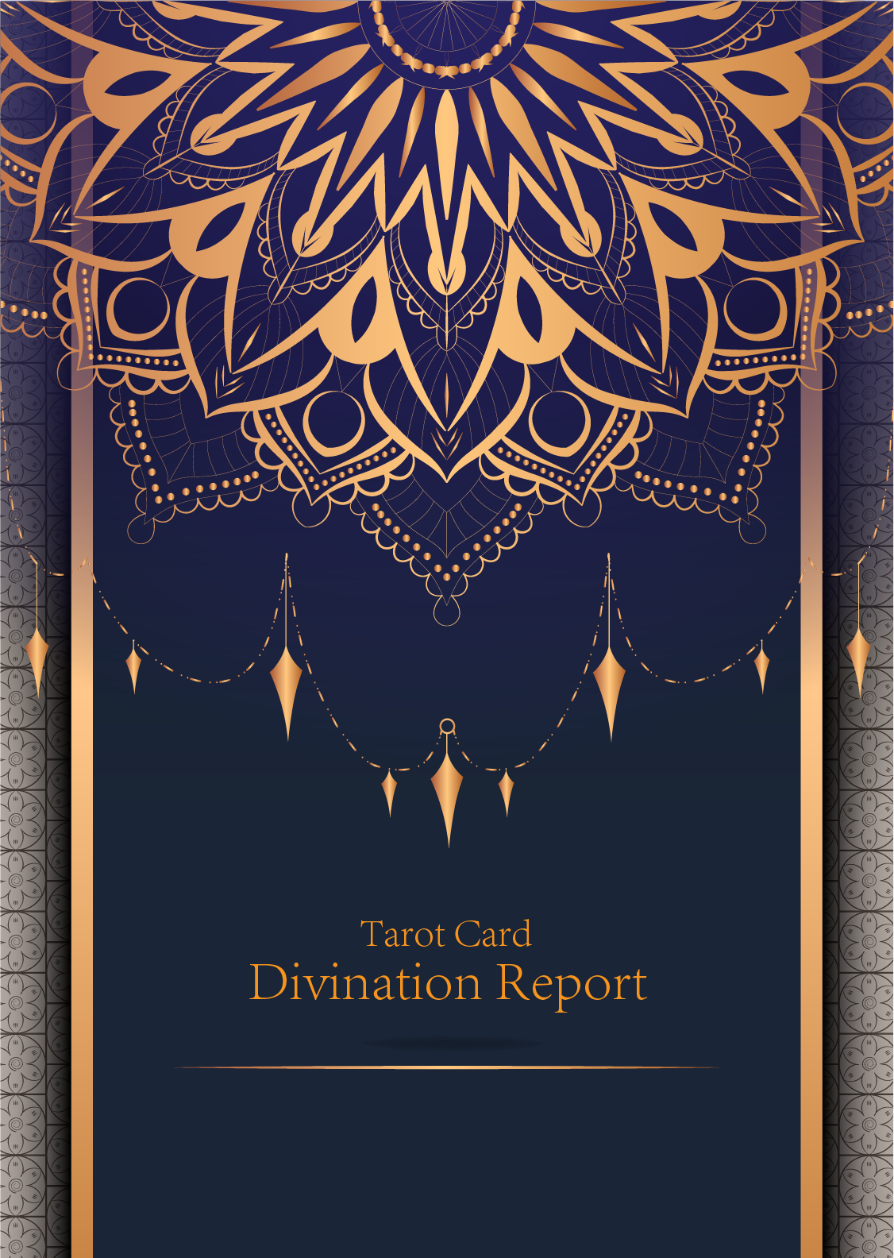

|  |
| --- |
| February 23, 2024 |

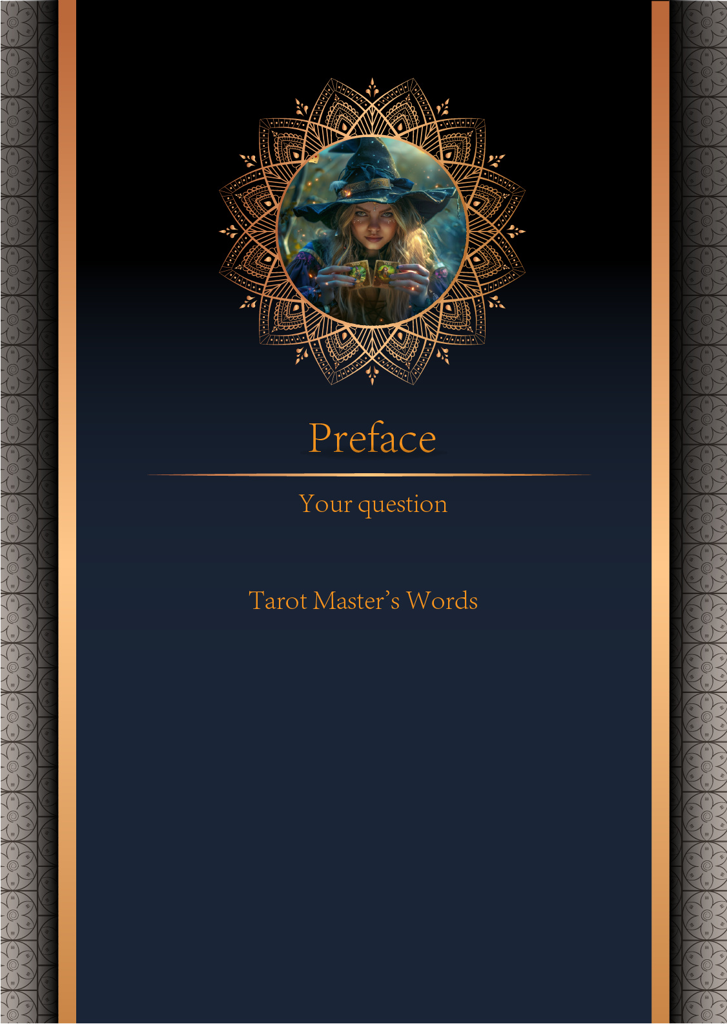

|  |
| --- |
| 我什么时候能结婚 |

|  |
| --- |
| Before we begin the interpretation, I would like to explain some important points to you. Tarot cards are not tools for predicting the future, but rather tools for guiding us to delve deeper into various situations in life. Therefore, when receiving the reading, please maintain an open mindset and trust your intuition. Our goal is to provide you with inspiration and guidance through the guidance of the tarot cards, helping you better deal with challenges and decisions in life. Alright, you can start reading now! |

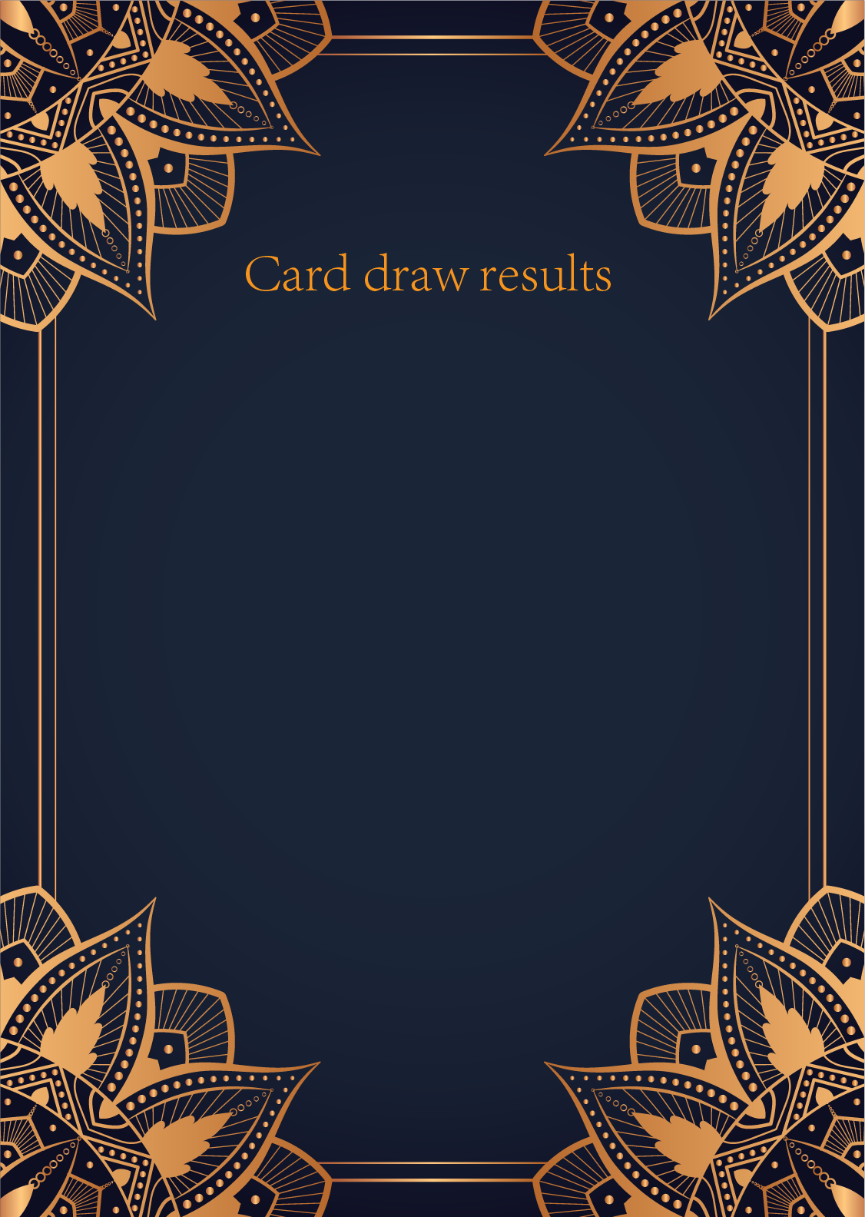

|  |
| --- |
| CardⅠ The Sun |
|  |
| The Sun card presents an feeling of optimism and fulfillment. This card represents the dawn which follows the darkest of nights. The Sun is the source of all the life on our planet, and it represents life energy itself. There is a child depicted in the card, playing joyfully in the foreground. A symbol of our innocence, it represents the happiness that occurs when you are in alignment with your true self. The child is naked, meaning that he has absolutely nothing to hide. The card also depicts the childhood innocence and absolute purity. This is particularly emphasized through the white horse upon which the child is riding. The horse here is also a symbol of strength and nobility. |

|  |
| --- |
| CardⅡ The Moon |
|  |
| When we encounter the Moon, we see a path that leads off into the distance. On either side of the path stand a wolf and a dog, representing our animalistic nature - one is civilized, and the other wild and feral. There is a crawfish that is crawling out of the pond from which the path stems from. In the distance, we can see two towers flanking the central path, once again alluding to the doubles visible in this card. Everything in this card seems to echo the other, as if to allude to two possibilities. When we walk down the path, we walk the fine line between conscious and unconscious, between the tamed side of civilization of the dog, and the forces of nature represented by the wolf. |

|  |
| --- |
| CardⅢ The Star |
|  |
| The Star card shows a woman kneeling at the edge of a small pond. She is holding two containers of water. One container pours the water out to the dry land, as if to to nourish it and ensure its fertility. The lush green land around her seems to say that it is working. One foot is inside the water which shows the spiritual abilities and inner strength of the woman. The other foot on the ground shows her practical abilities and strengths. Behind her, there is a large central star surrounded by seven small stars which represent the chakras. There is bird standing at a tree branch which represents the holy ibis of thought. The Star's astrological correspondent is Aquarius. |

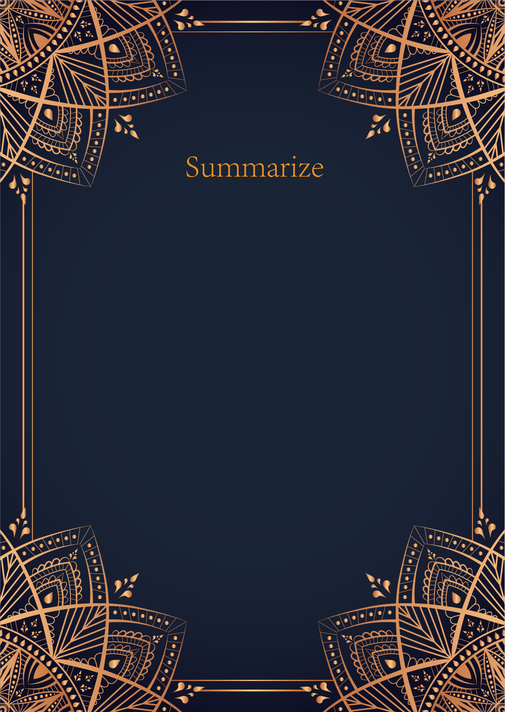

|  |
| --- |
| Ah, dear seeker, your question about marriage is one that is deeply woven into the fabric of your destiny. Let us decipher the mystical messages that the cards have revealed to us.  The Sun card, with its radiant energy and blessings from the heavens, shines brightly upon your path towards marriage. It signifies joy, harmony, and fulfillment in your relationships. This card tells us that the timing for marriage is auspicious, filled with positivity and happiness. It suggests that the union you seek is within reach, basking in the glow of newfound love and deep connections.  The Moon card, with its mysterious and intuitive energy, urges you to trust your instincts and emotions when it comes to matters of the heart. This card speaks of cycles and phases, hinting that there may be hidden emotions or uncertainties that need to be acknowledged and addressed before taking the leap into marriage. It encourages you to explore the depths of your soul and embrace the unknown with courage and ... |

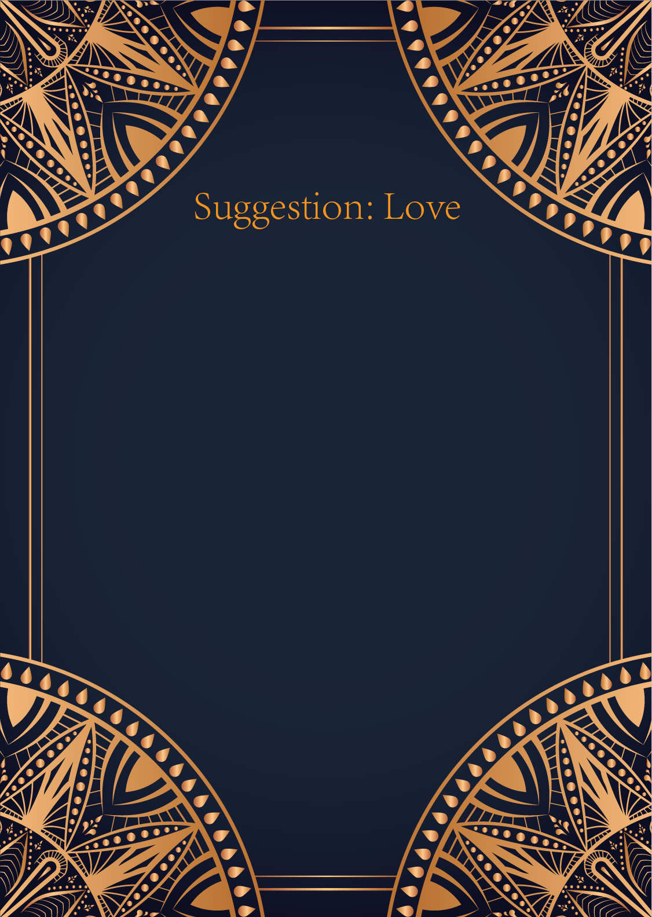

|  |
| --- |
| Ah, the Sun, the Moon, and the Star - three powerful cards representing illumination, intuition, and guidance in matters of the heart.   The Sun card shines brightly upon your love life, indicating joy, positivity, and clarity. It suggests that you should approach your relationships with confidence, optimism, and a child-like sense of wonder. Embrace the warmth and light that love brings into your life, and let your true self shine through in your interactions with others.  The Moon card, on the other hand, speaks to the realm of emotions, intuition, and hidden truths. It urges you to listen to your inner voice and pay attention to the subtle, sometimes mysterious, aspects of your relationships. Trust your instincts, explore your feelings, and be open to the ebb and flow of emotions that accompany matters of the heart.  Lastly, the Star card offers a sense of hope, inspiration, and spiritual connection. It encourages you to dream big, aspire to greater heights in your relationships,... |

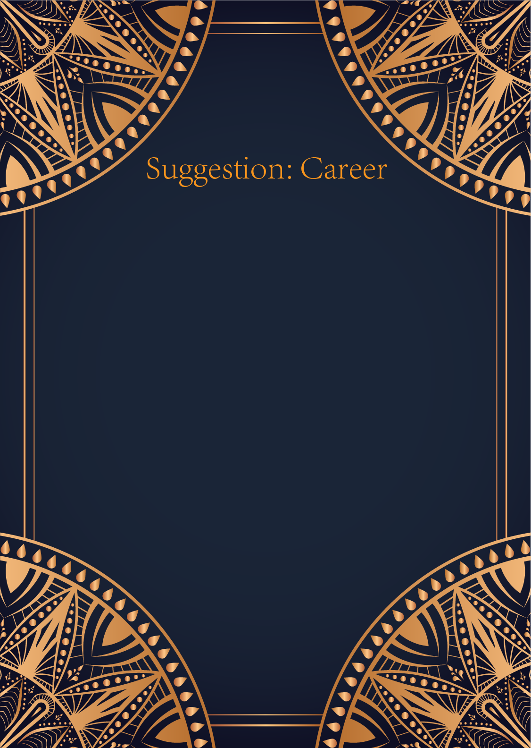

|  |
| --- |
| Ah, the Sun, the Moon, and the Star - a powerful trio of cards that speak of success, intuition, and inspiration in the realm of career and work.   The Sun card signifies success, vitality, and achievement in your professional life. It encourages you to shine brightly, to embrace your talents and skills, and to exude confidence in all that you do. This card suggests that you are on the right path towards reaching your goals and that your hard work will soon be rewarded. Remember to stay optimistic and to approach your work with a sense of joy and enthusiasm.  The Moon card represents intuition, dreams, and creativity in your career. It urges you to tap into your inner wisdom and to trust your instincts when making important decisions. This card may also indicate a need to explore your creative side and to embrace your imagination in your work. Pay attention to your emotions and subconscious thoughts, as they may hold valuable insights for your professional journey.  Lastly, the Star... |

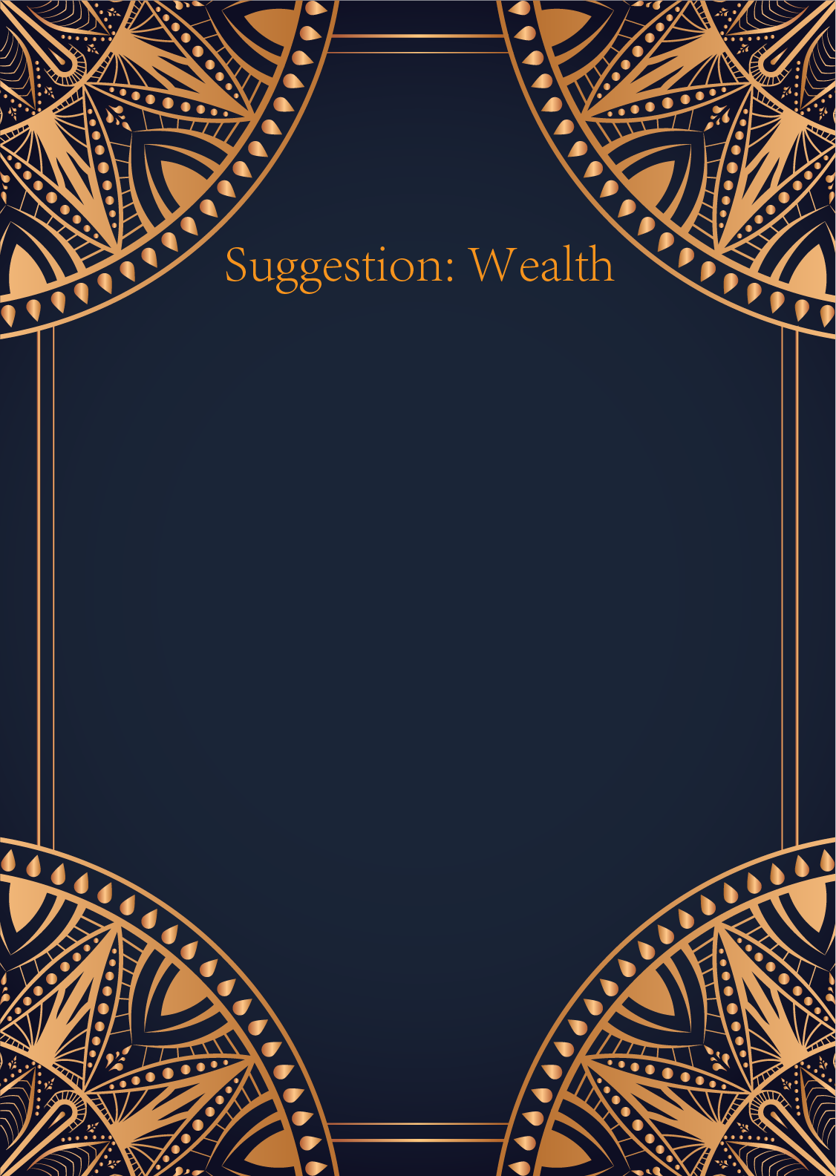

|  |
| --- |
| Ah, the Sun, the Moon, and the Star – a most auspicious combination indeed. In matters of finance, these cards speak of a harmonious balance between clarity, intuition, and guidance from above.  The Sun shines brightly upon your financial path, urging you to embrace optimism and confidence in your financial endeavors. This card reminds you to take bold and decisive actions towards your financial goals, trusting that success and abundance will follow.  The Moon, on the other hand, asks you to listen to your intuition and delve deep into your subconscious mind when it comes to financial decisions. There may be hidden factors at play that need to be brought to light. Trust your gut feeling and pay attention to your dreams and inner guidance.  Lastly, the Star offers you hope, inspiration, and guidance from the universe. This card encourages you to set lofty financial goals and have faith that they will be realized. Stay true to your visions and aspirations, knowing that the universe is conspiring to help you achieve them.  In summary, the Sun advises you to take action with confidence, the Moon urges you to trust your intuition, and the Star assures you that the universe is supporting your financial journey. By combining the energy of these three powerful cards, you are encouraged to stay positive, listen to your inner voice, and have faith in the abundance that is destined to come your way.  Embrace the energy of the Sun, Moon, and Star, and watch as your financial situation transforms and flourishes. The universe is on your side, guiding you towards prosperity and success. Trust in the cosmic forces at play, and you shall surely reap the rewards of your financial endeavors. |

